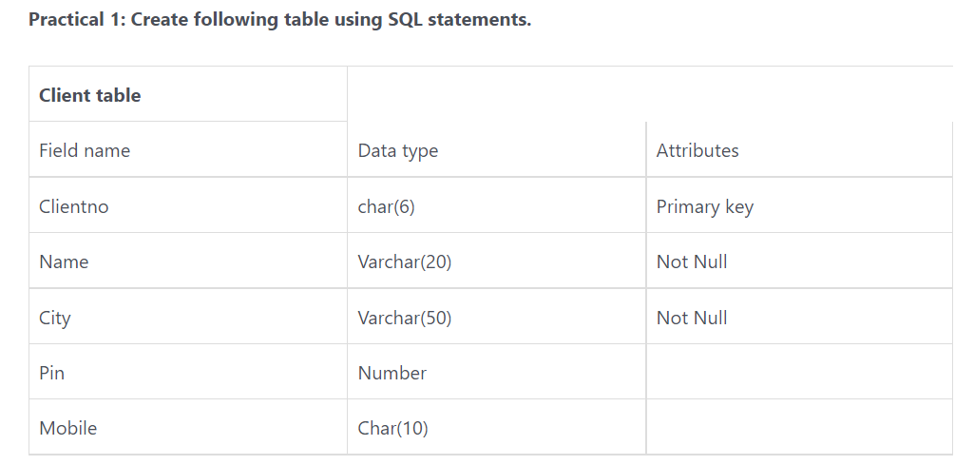

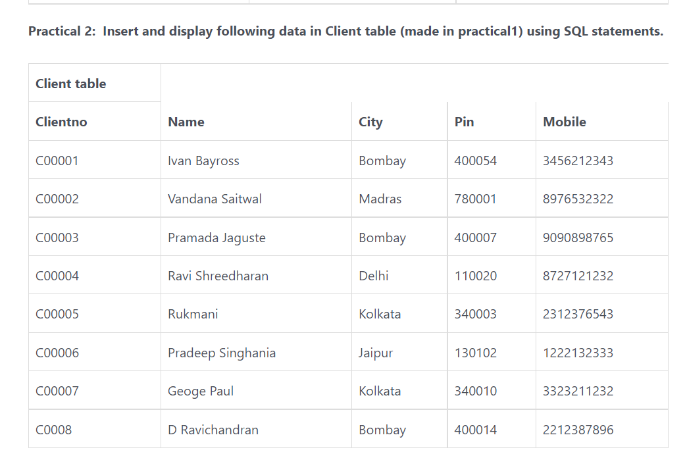

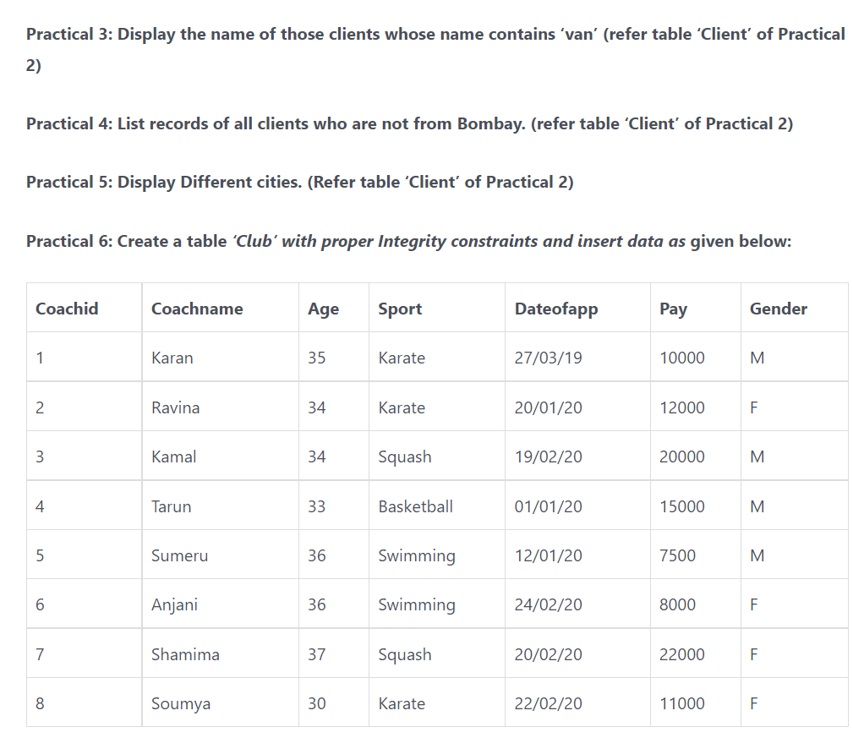

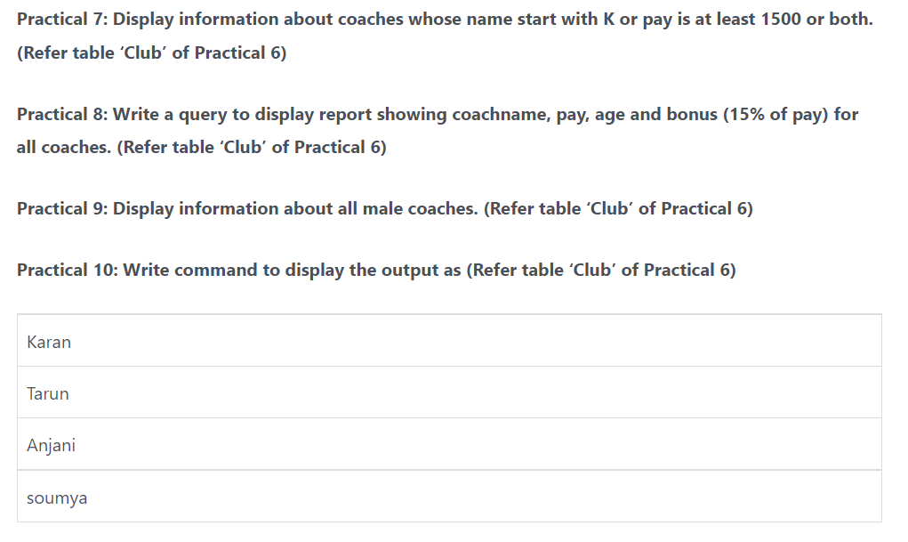

**program**

create database test;

use test;

create table table_table

(client_no varchar(10) primary key,

name varchar(25) not null,

city varchar(10) not null,

pin numeric(10),

mobile varchar(10)

);

insert into table_table(client_no,name,city,pin,mobile)values('C00001','IVANBAYROSS','BOMBAY','400054','2345678789');

insert INTO table_table(client_no,name,city,pin,mobile)values('C00002','VANDANASAITWAL','MADRAS','780001','2345678900');

INSERT INTO table_table(client_no,name,city,pin,mobile)values('C00003','PRADAMAJAGUSTE','BOMBAY','400007','2454565655');

insert into table_table(client_no,name,city,pin,mobile)values('c00004','RAVISREEDHARAN','DELHI','110020','5527678687');

insert into table_table(client_no,name,city,pin,mobile)values('C00005','RUKMANI','KOLKATA','340003','4523678910');

insert into table_table(client_no,name,city,pin,mobile)values('C00006','PRADEEPSIGHANIA','JAIPUR','130102','5634278989');

insert into table_table(client_no,name,city,pin,mobile)values('C00007','GOERGEPAUL','KOLKATA','340010','1234567890');

insert into table_table(client_no,name,city,pin,mobile)values('C00008','D RAVICHANDRAN','BOMBAY','400014','6238652903');

select * from table_table;

select * from table_table where name like '%van%';

select * from table_table where city != 'bombay';

select * from table_table group by city;

create database clubs;

use clubs;

create table cluubs

(

coachid char(2) ,

coachname varchar(25),

age char(2),

sport varchar(15),

dateofapp date ,

pay varchar(10),

gender varchar(1)

);

insert into cluubs(coachid,coachname,age,sport,dateofapp,pay,gender)values('1','karan','35','karate','27-03-19','10000','M');

insert into cluubs(coachid,coachname,age,sport,dateofapp,pay,gender)values('2','ravina','34','karate','20-01-20','12000','F');

insert into cluubs(coachid,coachname,age,sport,dateofapp,pay,gender)values('3','kamal','34','sqash','10-02-20','20000','M');

insert into cluubs(coachid,coachname,age,sport,dateofapp,pay,gender)values('4','tarun','33','basketball','01-01-20','15000','M');

insert into cluubs(coachid,coachname,age,sport,dateofapp,pay,gender)values('5','sumeru','36','swimming','12-01-10','7500','M');

insert into cluubs(coachid,coachname,age,sport,dateofapp,pay,gender)values('6','Anjali','36','swimmimg','24-02-20','8000','F');

insert into cluubs(coachid,coachname,age,sport,dateofapp,pay,gender)values('7','shanima','37','squash','20-02-20','22000','F');

insert into cluubs(coachid,coachname,age,sport,dateofapp,pay,gender)values('8','soumya','30','karate','22-02-20','11000','F');

select * from cluubs;

select * from cluubs where coachname like '%k%' or pay >=15000;

select * from cluubs where gender like 'm';

alter table cluubs add column bonus char(20);

update cluubs set bonus =.15*pay where coachid between 1 and 8;

select coachname from clubsbs coachid in (1,4,6,8)